Quality Assurance Surveillance Plan (QASP)

For

Western Currency Facility Operations and Maintenance (O&M) Security Equipment Services

Contract Number: TBD

COR  Keith A. Goodenough | DATE | BEP  CONTRACTING OFFICER  Terry Lawrence | DATE
 | 1/31/2024 |  | 1/31/2024

SUMMARY OF REVISIONS

Revision Dated | Revision page(s) number | Content | Position | Name

TABLE OF CONTENTS

Subject Page Number

1. Overview 4

2. Description of Services/Supply/Product 4

3. Roles and Responsibilities 4

4. Contract Quality Requirements 5

5. Government Surveillance 6

6. Non-Conforming Performance 6

7. Data Analysis 7

8. Acceptance of Services 7

9. COR Status Report 8

10. Contractor Performance Assessment Reporting System (CPARS) 8

11. COR/Quality Assurance Surveillance Files 8

12. QASP Changes 8

1. Overview.

1.1. Purpose. The purpose of this Quality Assurance Surveillance Plan (QASP) is to identify the methods and procedures the Government will use to ensure it receives the services under this contract as identified in the Performance Work Statement (PWS).

1.2. Intent. The intent of this QASP is to: 1) ensure Contractor performance meets or exceeds contract terms, conditions, and specifications; 2) hold the Contractor accountable for quality control; and 3) encourage the Contractor to take appropriate steps to control and improve quality. Accordingly, the Government will perform surveillance on the contract in accordance with this QASP but reserves the right to monitor the contract in any manner necessary, at any times necessary, and at all places necessary to ensure that the rendered services conform to contract requirements. The Government also reserves the right to perform quality assurance at the Subcontractor level and perform quality assurance at the contractor's place of business, if applicable. Resolution of non-conforming services discovered at the Subcontractor level will be addressed with the prime Contractor.

2. Description of Services.

2.1. Scope of Work. This is a non-personnel services contract to provide operations and maintenance services for the Western Currency Facility’s Security devices and components. The Government shall not exercise any supervision or control over the contract service providers performing the services herein. Such contract service providers shall be accountable solely to the Contractor who, in turn is responsible to the Government.
Operation and Maintenance of the security equipment includes scheduled preventive maintenance, unscheduled corrective maintenance, operations, and maintenance of all sub-components (i.e., access control, intrusion detection, closed circuit television), and other miscellaneous work. The Contractor shall, to the extent possible, minimize impacts on facility operations when performing all maintenance services. The Contractor shall establish and maintain a Preventative and Corrective Maintenance Program which is subject to approval by the COR.

The contractor shall provide all personnel, equipment, tools, materials, supervision, management, labor, materials, supplies and other items, as necessary, to plan, schedule, perform the operation & maintenance, reconfiguration and re-engineering, monitoring, and emergency repairs of the security equipment and all sub-components

2.2. Type of Contract. This is a firm fixed price contract

3. Roles and Responsibilities.

3.1. Government.

3.1.1. Contracting Officer (CO). The CO is the only person with the authority to enter into, administer, and or terminate contracts, and make related determinations and findings on behalf of the Government. Note: The only individual who can legally bind the Government.

3.1.2. Contracting Officer’s Representative (COR). The (COR) will be identified by separate letter. The COR monitors all technical aspects of the contract and assists in contract administration. The COR is authorized to perform the following functions: assure that the Contractor performs the technical requirements of the contract: perform inspections necessary in connection with contract performance: maintain written and oral communications with the Contractor concerning technical aspects of the contract: issue written interpretations of technical requirements, including Government drawings, designs, specifications: monitor Contractor's performance and notifies both the Contracting Officer and Contractor of any deficiencies; coordinate availability of Government furnished property, and provide site entry of Contractor personnel. A letter of designation issued to the COR, states the responsibilities and limitations of the COR, especially with regard to changes in cost or price, estimates or changes in delivery dates. The COR is not authorized to change any of the terms and conditions of the resulting order.

3.1.3. Contract Specialist. The official Government representative delegated authority by the Contracting Officer to administer a contract. This individual is normally a member of the appropriate Contracting/Procurement career field and advises on all technical contractual matters.
3.2. Contractor. A supplier or vendor awarded a contract to provide specific supplies or services to the government. The term used in this contract refers to the prime.

3.2.1. Contract Manager. The contractor shall provide a Contract Manager and a Deputy Contract Manager who shall be responsible for the performance of the work. The names of these persons must be designated in writing to the Contracting Officer. The contract manager and deputy shall have the full authority to act for the contractor on all contract matters relating to daily operation of this contract.
4. Contract Quality Requirements.

4.1. Contractor’s Quality Control Program. The Contractor’s quality control program is how the Contractor assures the work complies with the requirement of the contract. The Contractor shall ensure services are performed in accordance with this PWS. The Contractor shall identify, prevent, and ensure non-recurrence of defective services

4.2. Government Quality Assurance. The Government shall evaluate the Contractor’s performance under this contract in accordance with this QASP. This plan is primarily focused on what the Government must do to ensure that the Contractor has performed in accordance with the performance standards. It defines how the performance standards will be applied, the frequency of surveillance and minimum acceptable defect rate(s).

5. Government Surveillance.

5.1. Methods of Surveillance. The following Methods of Surveillance will be utilized in monitoring the Contractors’ performance:

5.1.1. 100% Inspection Reserved for the highest risk areas where consequence of failure is high (i.e. life or limb are threatened) or there is likelihood of mission failure.

5.1.2. Random Sampling - When a service is performed relatively frequently, and a statistically valid sample can be selected for audit. The most appropriate method for frequently recurring tasks.

5.1.3. Periodic Inspection - Planned sampling of a service at specific predetermined dates and times. May be appropriate for tasks that occur infrequently.

5.1.4. Customer Feedback. The Customer Complaint Record, Attachment 2, will be used to document/record all complaints. The following procedures will be followed when a complaint is received.

- The COR will investigate and determine the validity of the complaint.

- If the complaint is determined to be invalid, the COR will inform the person who submitted the complaint of the reason(s) as soon as practical.

- For validated complaints that are true contractual non-conformances, the procedures in paragraph 6 below will be followed.

5.2. Surveillance Schedule. A Surveillance Schedule will be created each month utilizing the COR Surveillance Schedule, Attachment 3. The schedule is “FOR OFFICIAL USE ONLY” and is not releasable to anyone other than authorized Government personnel. A copy of the Surveillance Schedule will be filed and will become part of the CORs file.

5.3. Surveillance Instructions/Checklists. Surveillance Checklists, Attachment 4, will be utilized and completed when surveillances are conducted.

5.4. Surveillance Documentation. The applicable Surveillance Checklist(s) will be completed when/as Surveillances are conducted. Completed Surveillance Checklist(s) will be filed in CORs file. The file will have ready access to the BEP Office of Acquisition.

6. Non-Conforming Performance. Non-conformance occurs when a Contractor fails to meet Contract or Task Order terms, conditions and/or specifications. All instances of non-conformance will be documented, and the Contractor will be notified. Resolution of non-conformance discovered at the Subcontractor level will be addressed with the prime Contractor. Non-conformance is classified as either: Level I (Minor); Level II (Major); or Level III (Critical).

6.1. Level I (Minor). Level I non-conformance is not likely to materially reduce the usability of services for their intended purpose or is a departure from established standards having little bearing on completing the contract requirement. Minor non-conformances can usually be corrected on the spot and can be issued to the Contractor through either a verbal or written Contract Discrepancy Report (CDR). However, the Government is still required to document verbal Level I CDRs. The COR may issue verbal Level I CDRs directly to the appropriate level of Contractor management. The COR will notify the CO as soon as practical when a verbal Level I CDR is issued and document them in their Monthly Reports. If the non-conformance cannot be corrected on the spot, the Contractor shall be given a suspense date to correct the deficiency. The CO will issue and sign written Level I CDRs, Attachment 5.

6.2. Level II (Major). Level II non-conformance is likely to result in failure of the services to meet contract requirements. Also, repeated discrepancies, a large number of documented Level I CDRs and trends indicating failure of the Contractor’s quality control program can be classified as Level II CDRs. The CO issues all Level II CDRs in writing, Attachment 5. The COR will notify the CO as soon as practical when a major non-conformance is identified.

6.3. Level III (Critical). Level III non-conformances result in hazardous or unsafe conditions due to the manner in which the services are performed; prevent or impact a vital agency mission as a result of performance; or are for repeated or uncorrected Level II CDRs. The Contracting Office Director or Deputy Director issues written Level III CDRs. The COR is responsible for notifying the CO immediately upon discovery of a critical non-conformance.

6.4. Documenting CDRs. Documentation, as a minimum, will include: the Contract or Task Order number; reference to the specific contract requirement; the specific discrepancy to the requirement; where it was discovered; the date and time it was discovered; Contractor representative who was notified; and the suspense date for Contractor response/corrective action.

6.5. Tracking and Resolving CDRs. All CDRs, verbal and written, regardless of issuer will be included in the COR’s Monthly Report. The COR and CO shall track CDRs to ensure the Contractor identifies and takes appropriate corrective action to the root cause and the specific non-conformance is corrected within the required timeline. The CO will make a final written determination of the Government’s remedies if the non-conformance is not corrected by the Contractor after receiving notice and a reasonable opportunity to correct the work.

7. Data Analysis. Data Analysis will be performed to identify trends in cost, schedule and/or performance risks. The results of Data Analysis will be documented in COR Status Reports and may be used to adjust surveillance schedules, increase or decrease surveillance, if deemed appropriate. Negative trends noted using Government data/observations could result in issuing the Contractor a Contract Discrepancy Report. Trends noted using Contractor data will not result in a CDR unless the Contractor is not addressing the negative trend.

8. Acceptance of Services. When all services have been deemed acceptable and there is documented objective quality evidence to support acceptable performance the COR will accept the services provided and authorize payment of the Contractor. This is accomplished by approving the Contractor’s Receiving Reports via IPP.

9. COR Status Report. COR Status Reports will be submitted on a Monthly basis to the Contracting Officer. COR Status Reports will provide a synopsis of the Contractors performance for the inclusive dates of the report. The synopsis will contain a summary of: surveillances performed; Customer Feedback, if any; CDRs, if any; an analysis of the Contractors performance; recommended adjustments to surveillance schedules; and any other pertinent contract information. Completed Surveillance Checklists and CDRs, if any, will be included as attachments to COR Status Reports or uploaded separately in the Miscellaneous Documents Section of the CORs’ Online file.

10. Contractor Performance Assessment Reporting System (CPARS). Documented surveillance data (COR Status Reports, Completed Surveillance Checklists, Customer Feedback and CDRs, if any) will be used to support CPARS ratings.

11. COR/Quality Assurance Surveillance Files. The official COR/Quality Assurance Surveillance File will be maintained by the COR.

12. QASP Changes. This QASP is a living document and, as such, may be changed as needed based on Data Analysis (trends), contract modifications, etc. The COR will send any recommended changes to the Contracting Officer for approval and the Contracting Officer must approve all changes.

Attachments:
1. Performance Requirements Summary (PRS)
2. Customer Complaint Record
3. Surveillance Schedule
4. Surveillance Checklist(s)
5. Contract Discrepancy Report

Attachment 1

Performance Requirements Summary (PRS)

The contractor services requirements are summarized into performance objectives that relate directly to mission essential items. The performance threshold describes the minimum acceptable levels of service required for each requirement. These thresholds are critical to mission success. Government surveillance of contractor performance is not limited to the Performance Objectives as outlined in this PRS. The Government reserves the right to conduct compliance surveillance of any contractual requirement of this acquisition.

Performance Objective | Performance Standard | Performance Threshold  Acceptable Quality Level (AQL) | Incentives (Positive or Negative)
5.2 Scheduled Preventive Maintenance (PM). | 1) Submit a detailed Preventive Maintenance Plan consistent with manufacturer’s recommendations within 30 days of contract award.  2) Conduct PM IAW approved plan during the performance period. | 1) No deviation.  2) 85% of all items in the plan completed on time. | Positive / Negative CPARS evaluation.
5.2.4.2. Isolation Zone | The Contractor shall maintain the ground surface between the exterior perimeter security fences to ensure that devices located between the fences operate as specified. Such maintenance shall include eliminating all visible signs of vegetation between the fences as well as noticeable protrusions or indentations of surface gravel between the fences. | 10% deviation. | Positive / Negative CPARS evaluation.
5.2.4.3. Exterior Lighting | The Contractor shall provide corrective maintenance / repair, for exterior lighting, on a quarterly basis. Corrective maintenance / repair will be done during the same period of time the exterior camera preventative maintenance is being done. Weather conditions must be taken into consideration in determining when the corrective maintenance /repair will actually be done. | 10% deviation. | Positive / Negative CPARS evaluation.
5.2.4.4 Magnetometers and X-Ray Machines | The contractor shall provide preventative and corrective maintenance, test, and calibration (as required) for the magnetometers and X-ray machines on a weekly basis | No deviation. | Positive / Negative CPARS evaluation.
5.2.4.5 As-Built Drawings | The Contractor shall maintain As-Built drawings of all Integrated Security System components. Drawings will be kept electronically on the BEP LAN and printed as requested by the COR, as he/she deems necessary. Drawings will be updated no less than 5 days after a system alteration. Drawings, regardless of media type shall not be removed from the facility without explicit written permission from the COR, Physical Security Branch Manager, or Security Division Manager. | 10% deviation. | Positive / Negative CPARS evaluation.
5.2.4.6 Electronic Communication | The primary means of electronic communication or file transfer shall be made using the BEP Local Area Network (LAN). The secondary means of file transfer may be accomplished via BEP approved media (e.g. BEP provided thumb drive, external hard drive). When files are provided by this media, encryption and passwords are not necessary. The above-mentioned media will be marked as required by the COR. Use of non-BEP networks or email systems is strictly prohibited. | No deviation. | Positive / Negative CPARS  evaluation.
5.2.4.7 Bench Stock | The contractor shall identify and present recommended bench stock quantities to have on hand for immediate employment as directed, 30 days after contract award and then monthly thereafter. These recommendations shall be electronically submitted to the COR for approval. Upon approval, the contractor shall obtain the materials and supplies and appropriately store them in a government provided storage area. | 10% deviation. | Positive / Negative CPARS  evaluation.
5.2.4.8 Property Accountability | The Contractor shall maintain an up-to-date detailed inventory of all O&M equipment. All new equipment shall be added to the inventory and any disposed of/removed equipment will be deleted from the inventory. The inventory will be maintained in MS Excel and electronically submitted to the COR monthly. In addition, the spreadsheet will be stored and available on the BEP LAN for review at any time by the COR. | 10% deviation. | Positive / Negative CPARS evaluation.
5.2.4.9 Locks | The Contractor shall be responsible for all locksmith services. This includes PMs, changing and rekeying, and the cutting and stamping of keys. Locksmith service requests will be completed within 1 day for low security locks and within 4 hours for high security locks. | 10% deviation. | Positive / Negative CPARS evaluation.
5.3 Unscheduled Corrective Maintenance | Contractor will respond and correct all routine repairs by end of second full duty day. | 10% deviation. | Positive / Negative CPARS evaluation.
5.3.2 Emergency Corrective Maintenance | Contractor will respond to emergency corrective maintenance within 2 hours of notification and Contractor shall correct/repair problem. | 10% deviation. | Positive / Negative CPARS evaluation.
5.4 Product Security Station CCTV Sub-system Operation | Contractor will provide monitoring, reviewing, retrieving services 24/7. | No deviation. | Positive / Negative CPARS evaluation.
5.5 Reconfiguration and Re-engineering Requirements | 1) Contractor shall provide proposed designs NLT third day after WO received.  2) Design shall include provisions IAW 5.5.3.2.  3) Contractor shall complete the work IAW approved design and timelines. | 1) 10% deviation.  2) 10% deviation.  3) 10% deviation. | Positive / Negative CPARS evaluation.

Attachment 2

Customer Complaint Record

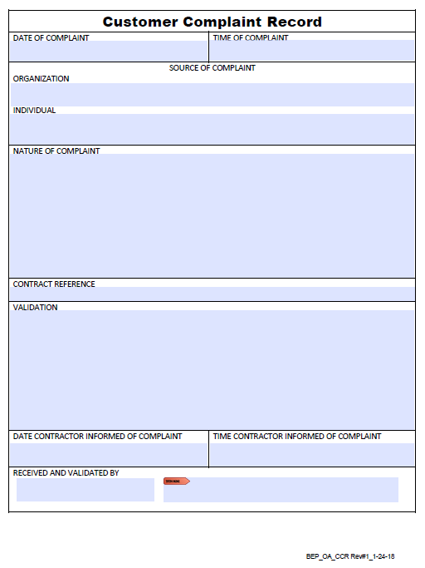

Attachment 3

Surveillance Schedule
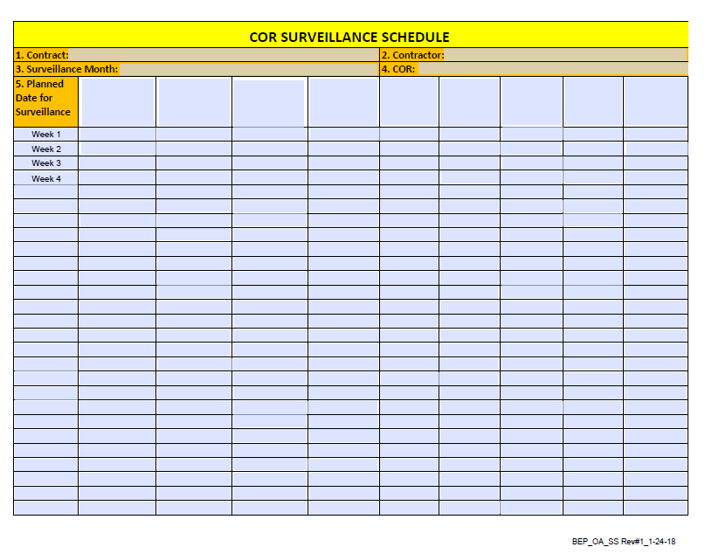

Attachment 4

Surveillance Checklist(s)

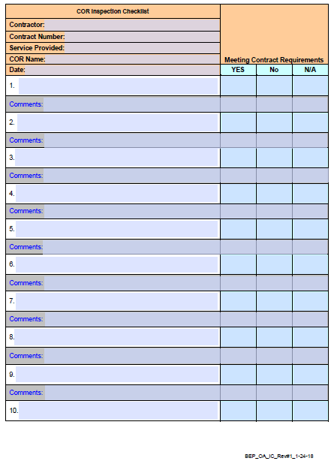

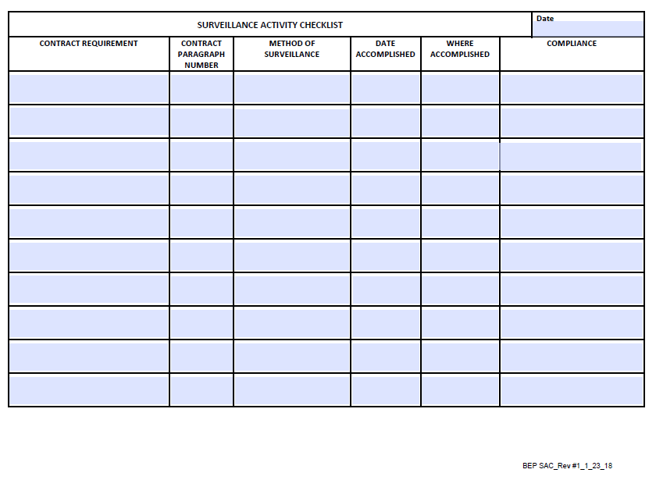

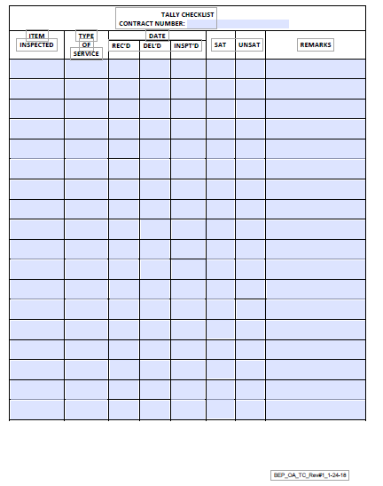

Attachment 5

Contract Discrepancy Report
